

ICT710 Assignment 3

Group Participation Form

This form is to be completed by the group and returned to your tutor/lecturer as soon as possible.

We, the undersigned, agree to contribute individually and as a team to complete the Group Assignment for ICT710 Interaction Design and Usability in the time specified. (It should be noted that failure to participate in a group may result in a fail for the assignment component of the subject.)

Group membership:

 | Surname | First name | Student ID | Date Signature
1. | Jayasinghe Arachchige | Udith Madushan Jayasinghe | 69191 | 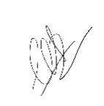  19/10/26
2. | Nallavelli | Naveen | 65748 | 19/10/26 naveen
3. | 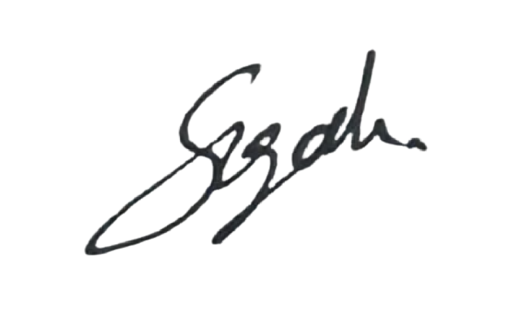  Kapurubandara Arachchige Don | Piyum Sugandha | 68750 | 19/10/26
4. | kandela | Pranay___________________ | 65924__________ | 19/10/26 _________pranay____________
5. | Venkata krishna sai | Yechuri | 66833 | 19/10/26 krishna

* All members in the team will receive the same mark for an assignment, unless there are extenuating circumstances whereby an
individual’s mark has to be altered by the tutor/lecturer, or if the peer group assessment warrants it.

** Team members should contact their tutor/lecturer immediately if problems arise within the team that may cause completion of an
assignment to be severely delayed, or the quality of the submission to be substantially lowered.

